Policy Brief

Satellite based mapping of lakes and climatic variations in the
Ruizi and Katonga Catchments, Uganda
Barasa bernar

Climatic variations cause significant impacts on the sensitivity of water resources in Uganda’s dryland areas
Barasa Bernard

Introduction

Climatic variations alter freshwater ecosystems but specifically the effects vary from one region to another and type of waterbody, the effects may manifest through an increase/decrease in nutrient/sediment loading, residence time and water level (Mooij et al., 2005; Herold et al., 2009). The effects are accelerated by climatic variations such as precipitation, evapotranspiration and other meteorological components or by changes in the runoff characteristics (such as land use/cover changes) in the catchment (Muvundja et al., 2014). The observable and potential effects of climate change on the fresh water resources include flooding, drought, change in the frequency and distribution of rainfall, drying up of river and receding of water bodies among others (Urama and Ozor, 2010).

The Inter-governmental Panel on Climate Change (IPCC) predictes an increase in the global average surface temperatures from 1.4 to 5.8◦C for the year 2100 (Houghton et al., 2001; Chang et al., 2002). The anticipated increase is already apparent in Uganda because the fastest warming has been experience in the south-west, where the rate was approximately 0.3◦C per decade. In the last century, the frequency and intensity of extreme climatic events have been generally on the increase such as the 1991-2000 decade alone peak observation of seven drought episodes (Kaggwa et al., 2009). However using these changes as indicators of climate change and linking them with geographical information systems data and socio-economic aspects are steadily gaining recognisition especially in the tropics. Understanding this linkage is significant since the future projections for both Ruizi and Katonga river catchments point to a general increase in rainfall intensities (Nyeko-Ogiramoi et al., 2010).

This study aimed to assess the mean annual monthly extent of lakes in relation to their sensitivity to climatic variations in both Ruizi and Katonga catchments. This is important for water resources and climate-monitoring and management since the catchments are significant reservoirs for Lake Victoria.

Both Ruizi and Katonga catchments are located in the Lake Victoria Management Zone and lie in the southern part of the cattle corridor of Uganda (Dryland) . The rivers originate from the hillslopes found in Western Uganda and later discharge their waters into Lake Victoria (Figure 1). The size of Ruizi catchment is 8,554.7sq.km, while Katonga is 13,842.8sq.km.

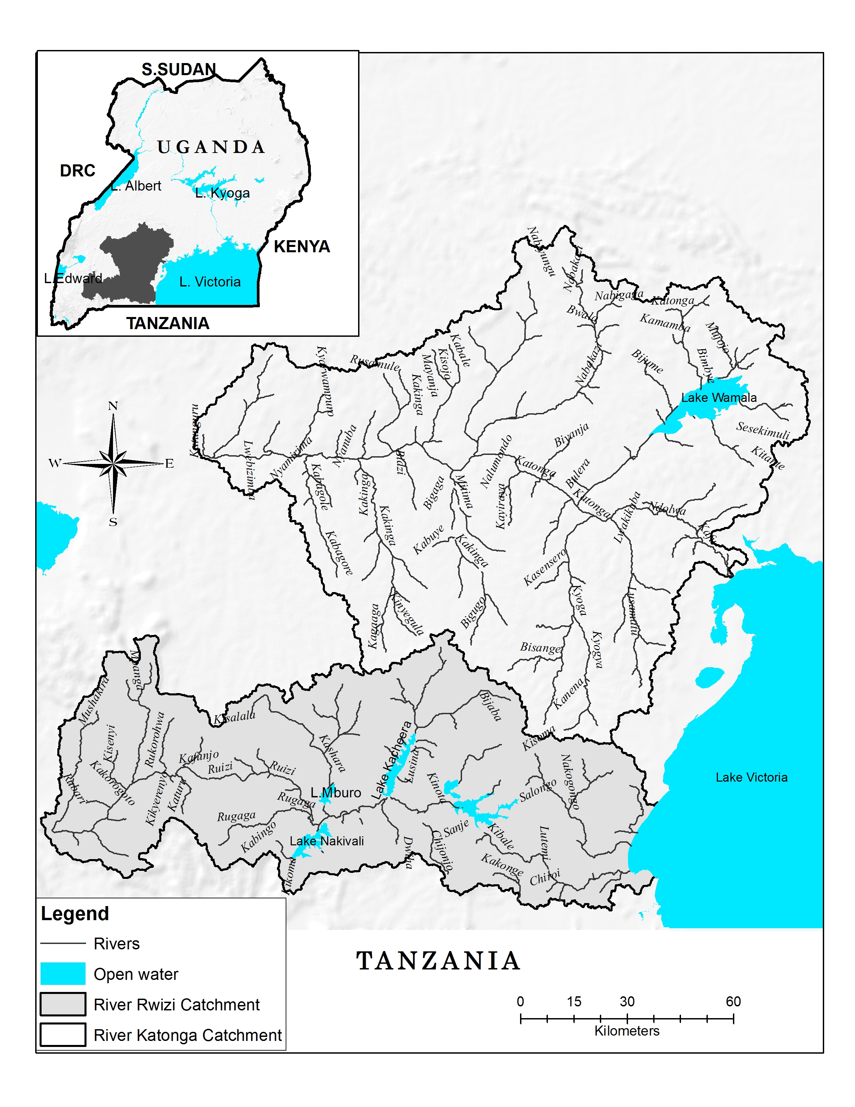

Figure 1: Ruizi and Katonga river catchments

Approaches

- One set of cloud free Landsat images of year 1986 and 2014 were selected after every three months interval (Jan-March; April-June; July-September; October-December) to quantify the extent of water body sizes. The images were classified using a mean-shift based segmentation method (figure 2).
- The annual monthly mean values from the classification results were considered
- The sensitivity of both catchments to climate variability were assessed using climate elasticity of both streamflow (Ruizi) and lake water levels (Katonga)
- A household survey was conducted in 2014 to examine and validate the occurrence and re-occurrence of climatic variations in relation to measured data in both catchments
- Meteorological & hydrological data was acquired from the Ministry of Water & Environment
- The Giovanni Merra Monthly data set was used develop a correlation map between precipitation and total runoff for the period 1986-2014

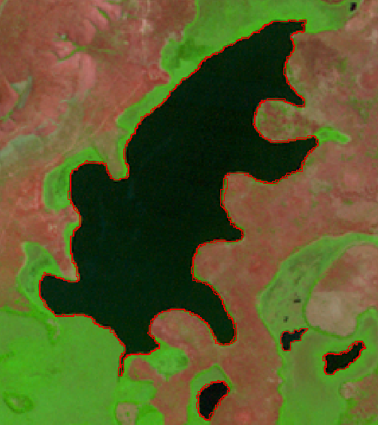
1986
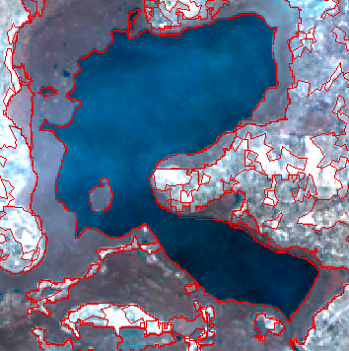
2014

v
Figure 2: segmented Landsat images for year 1986 and 2014

Key findings

- The period January-March highly reflect the effects of climate variability than May and October period as experienced by both catchments for the last 30 years.
- Drought is the most climatic variable that causes significant impacts on the water resources. This is followed by hailstorms and floods.
- The most prevalent periods were 2010-2013, 1998-2001 and 1994-1997 which experienced significant climatic variations (figure 3)
- In Ruizi catchment, the highest change/decrease in the lake surface area between 1986-2014 was experienced from Lakes Victoria (22.7%), Nakivali (4.4%) and Kijanebalola (0.7%) . Whilst a slight increase was recorded for Lakes Kacheera and Mburo.
- In Katonga catchment, the surface area of Lake Wamala decreased by 62.3sq.km between 1986 and 2014 (figure 4).

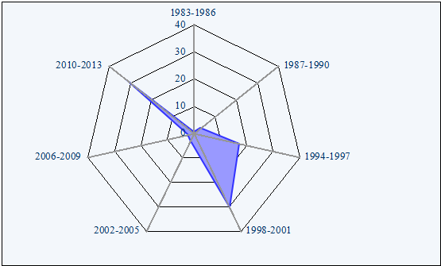
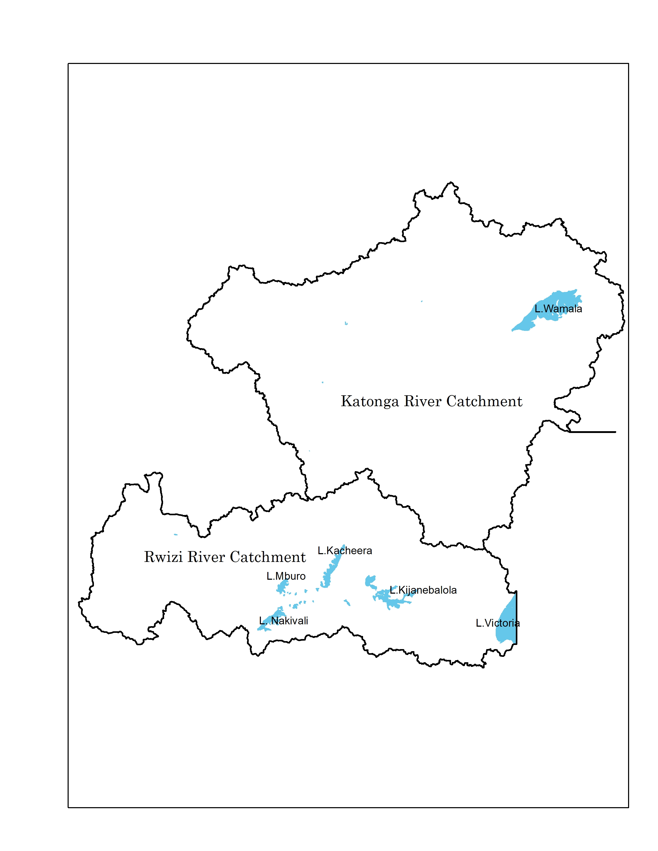
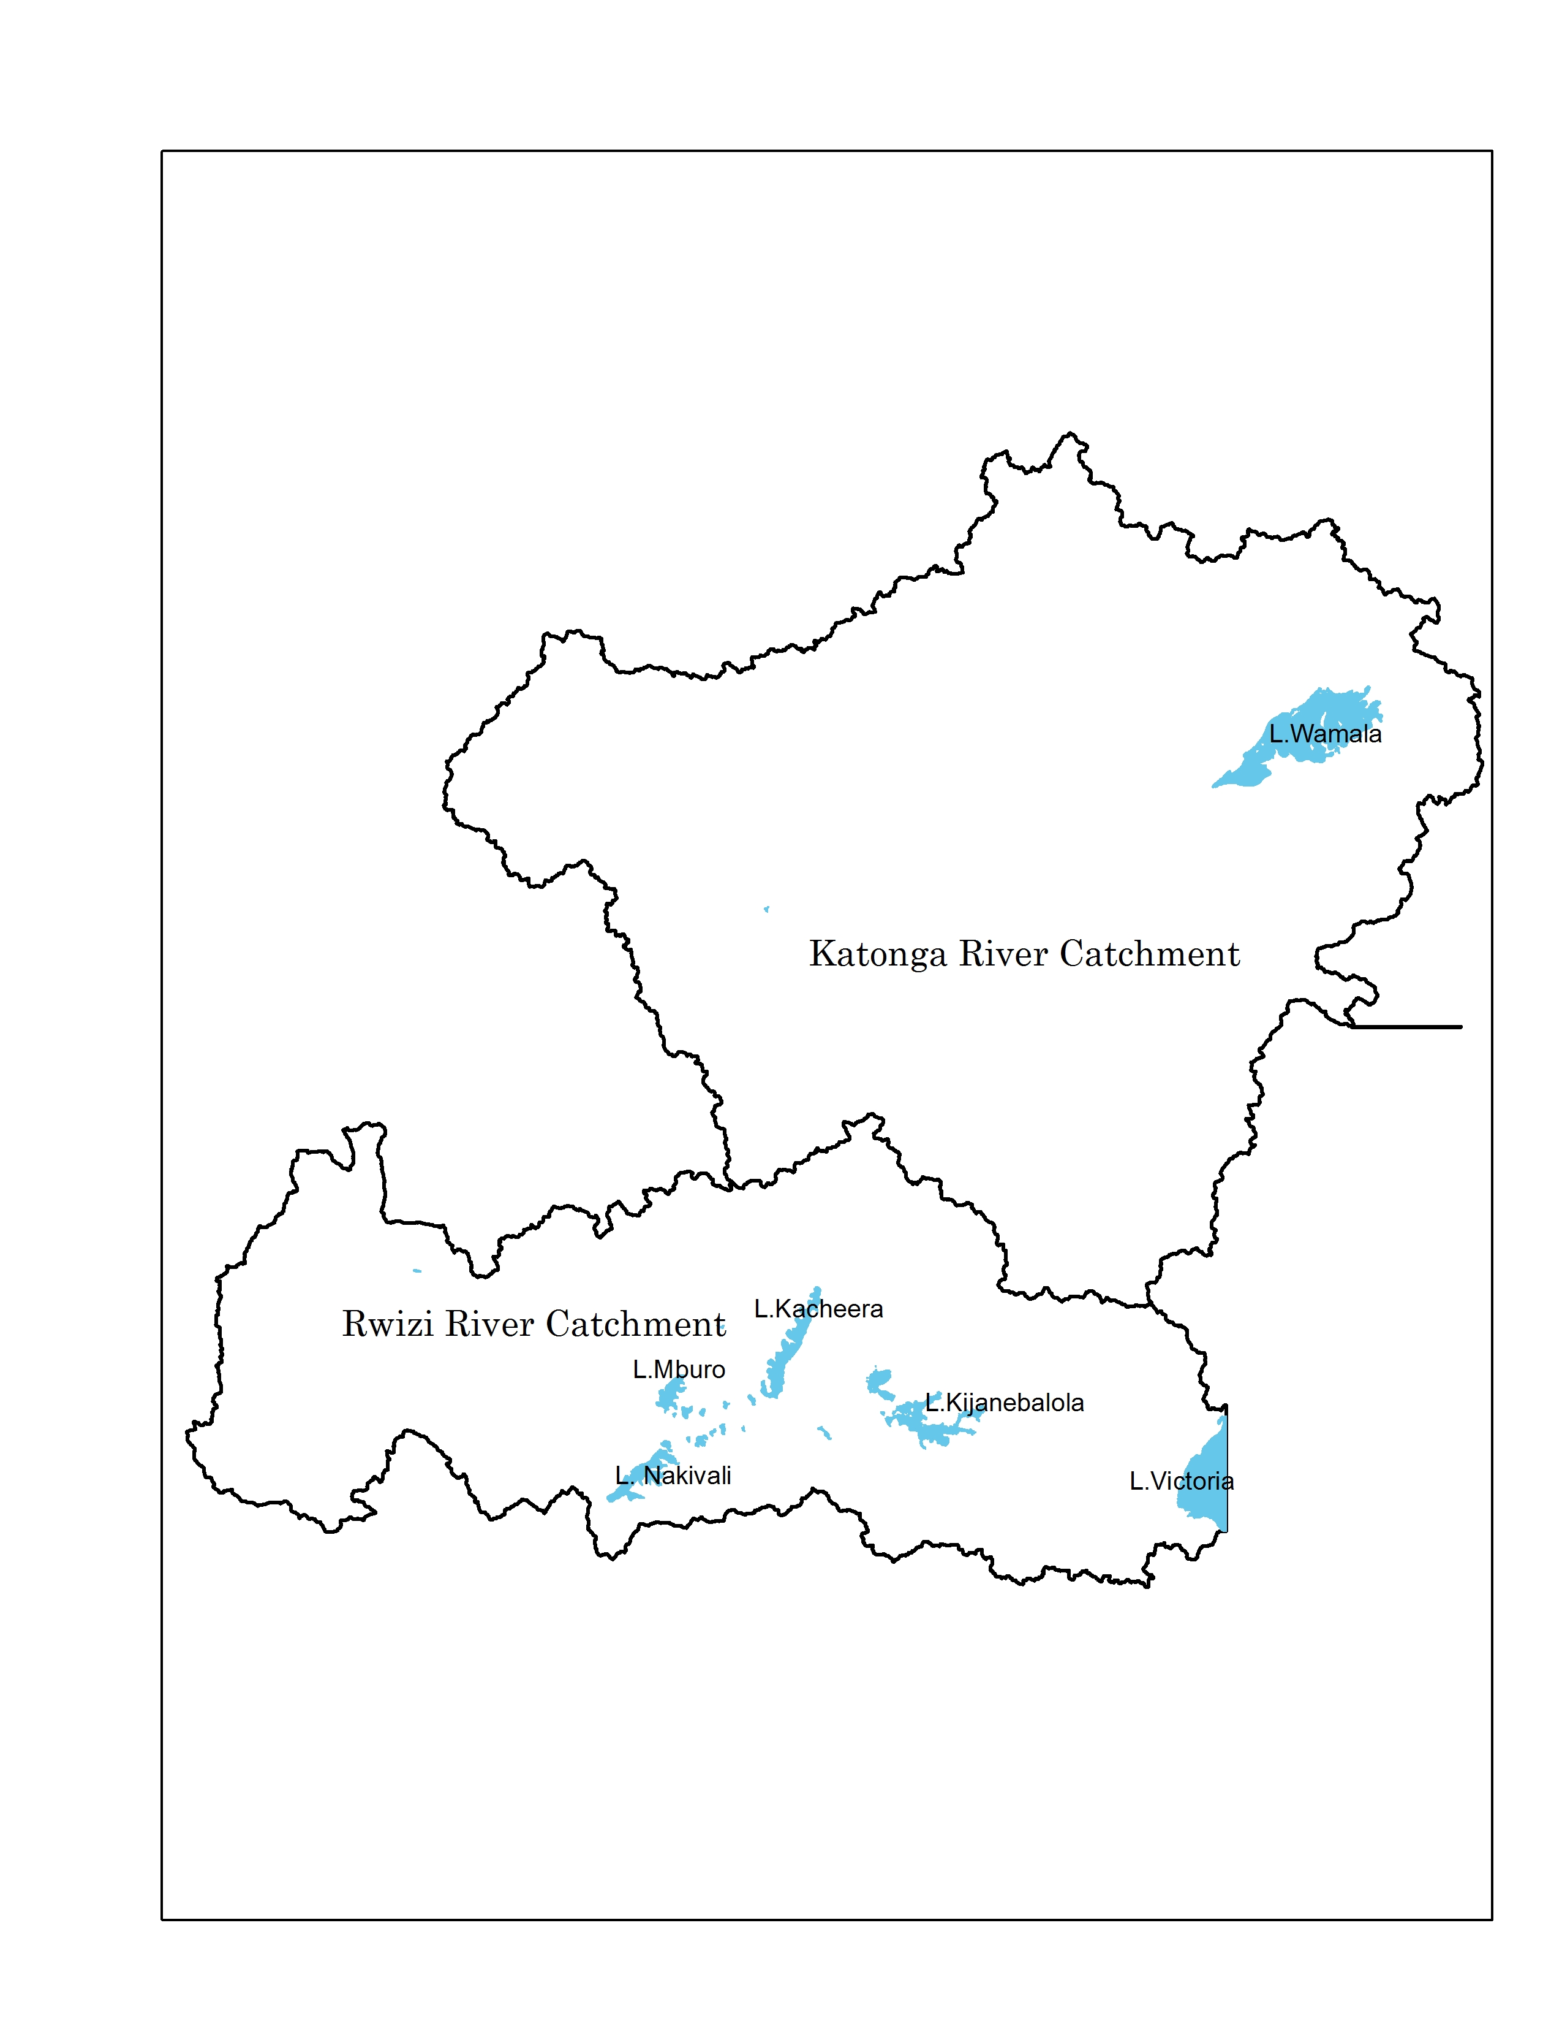
1986
2014

Figure 3 shows climatic shocks experienced in the catchment

Figure 4 shows the mean annual wet monthly classification extents for the water bodies for year 1986 and 2014 in both Ruizi and Katonga catchments

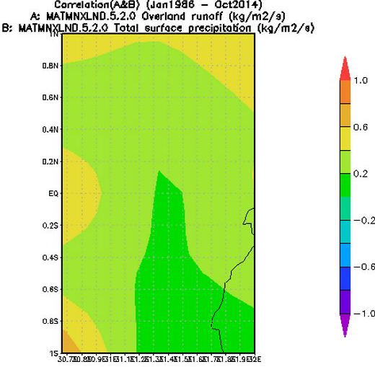
- A very insignificant increase in the surface extents of water bodies in the months that experienced rain was noticed
- The results from the power law model and the linear statistical model estimated that Katonga catchment is highly sensitive to changes in climatic variations than Ruizi catchment
- The changes in precipitation also reflected the changes in both the streamflow and water levels
- Based on the correlation between precipitation and total surface runoff, the Katonga river catchment experienced a relatively higher rate of total surface runoff than Ruizi (figure 5)
- However, the intensity of total surface runoff was highly experienced in the Ruizi catchment

Katonga catchment

Ruizi catchment

Figure 5 shows correlation map between overland runoff and total surface precipitation for year 1986 and 2014

Implications and recommendations

- The frequency of drought events has reduced and is likely to reduce further if there are no holistic watershed conservation measures / strategies adopted to combat the events

- A relatively slight increase was noticed in the area covered by water bodies found in the protected areas. Therefore, lessons need to be learned from the protected areas in terms of monitoring and conserving water resources

- Precipitation is the highest determinant of water level and streamflow variations. Land and water conservation measures implemented in both catchments should majorly aim at water retention

- If the intensity of total surface runoff is not controlled from the highlands in the Ruizi catchment, then this is ought to spread to other low lying areas and this will increase further the recedence of lakes in catchment through increased sediment loading

- Water resource managers need to base their catchment management strategies based on measured climatic variations at catchment level other than relying on the national wide findings (decentralisation of climate data collection)

References

- Kaggwa, R., Hogan, R., and Hall, B. (2009) Enhancing the Contribution of Weather, Climate and Climate Change to Growth, Employment and Prosperity. UNDP/NEMA/UNEP Poverty Environment Initiative, Uganda
- Houghton, J. T., Ding, Y., Griggs, D. J., Noguer, M., Van Der Linden, P. J., Dai, X., Maskell, K, & Johnson, C. A. (2001). Climate change 2001: the scientific basis. Contribution of working group I to the third assessment report of the international panel on climate change.
- Herold, M., Woodcock, C., Cihlar, M., Wulder, M., Arino, O., Achard, F., ... & Sessa, R. (2009). Assessment of the status of the development of the standards for the Terrestrial Essential Climate Variables: T9 Land Cover. FAO, GTOS report
- Nyeko-Ogiramoi, P., Ngirane-Katashaya, G., Willems, P., & Ntegeka, V. (2010). Evaluation and inter-comparison of Global Climate Models’ performance over Katonga and Ruizi catchments in Lake Victoria basin. Physics and Chemistry of the Earth, Parts A/B/C, 35(13), 618-633.

